Hannah Bonotto

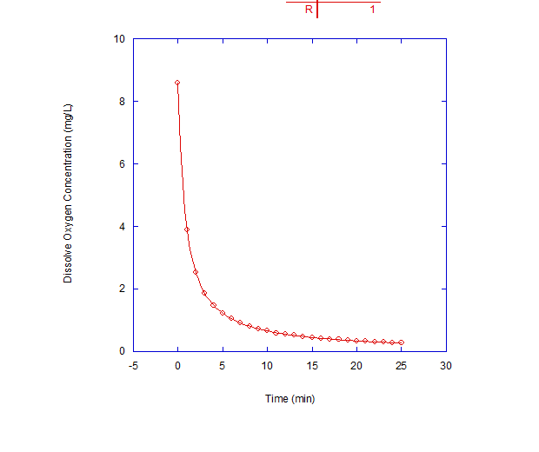

Figure 1. Measured dissolved oxygen concentration versus time during degradation of acetate. Circles represent data points while line represents fit to a second order curve for $k=0.1405\frac{L}{mg*s}$.

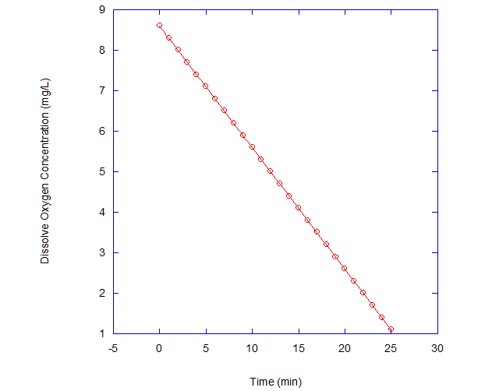

Figure 2. Measured dissolved oxygen concentration versus time during degradation of acetate. Circles represent data points while line represents fit to a zero order curve for $k=0.3\frac{mg}{L*s}$.

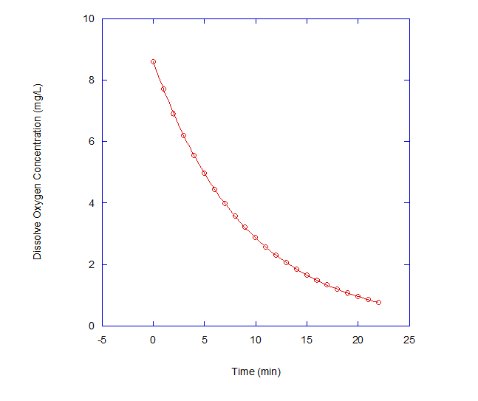

Figure 3. Measured dissolved oxygen concentration versus time during degradation of acetate. Circles represent data points while line represents fit to a first order curve for $k=0.11001s^{-1}$.